PROJECT REPORT

**1. INTRODUCTION**

*1.1 OVERVIEW*

The project aims to develop and implement a CRM system to track the progress and performance of a candidate with internal marks. The system will allow educators and administrators to easily record and access information about the candidate's academic performance, attendance, and engagement. The project will involve the selection and customization of a CRM platform, defining data requirements, setting up the system, training the team, and ongoing monitoring and evaluation..

**System Requirements:**

The system requirements for the CRM system include the need to track and record academic performance, attendance, and engagement data. The platform must have features and functionality that can meet these requirements, as well as being customizable to match the specific needs of the project. Additionally, the platform must be able to integrate with other systems if necessary.

**Platform Selection and Configuration:**

The process of platform selection and configuration involves evaluating various CRM platforms and selecting the one that best meets the project requirements. Once the platform has been selected, customization and configuration must be done to ensure that it matches the system requirements. It is important to ensure that the platform can be integrated with other systems if needed.

**Implementation and Training:**

The implementation and training phase is crucial in ensuring the successful deployment of the CRM system. A detailed implementation plan must be developed, and the system must be set up and tested to ensure its functionality. Team members must be trained on how to use the system effectively to maximize its benefits.

**System Monitoring and Evaluation:**

The CRM system must be monitored regularly to ensure its performance is up to standard. System data must be analyzed, and reports generated to assess the system's effectiveness. Any areas for improvement must be identified, and necessary changes made to the system.

*1.2 Purpose*

The purpose of this project is to develop and implement a CRM system that can track the progress and performance of candidates with internal marks, improving academic record-keeping, tracking, and decision-making. By leveraging technology, educators and administrators can access candidate data easily and make informed decisions.

The project aims to create a more efficient and effective academic environment that better serves the needs of candidates and educators. The CRM system will enable educators and administrators to work collaboratively and communicate effectively, leading to better decision-making and a better academic experience for candidates.

Ultimately, the objective of the project is to improve the academic experience for all stakeholders by enhancing academic record-keeping, tracking of internal marks, and decision-making. The CRM system will leverage technology to create a more efficient and effective academic environment.

**2. Problem definition and design thinking**

*2.1 Empathy map*

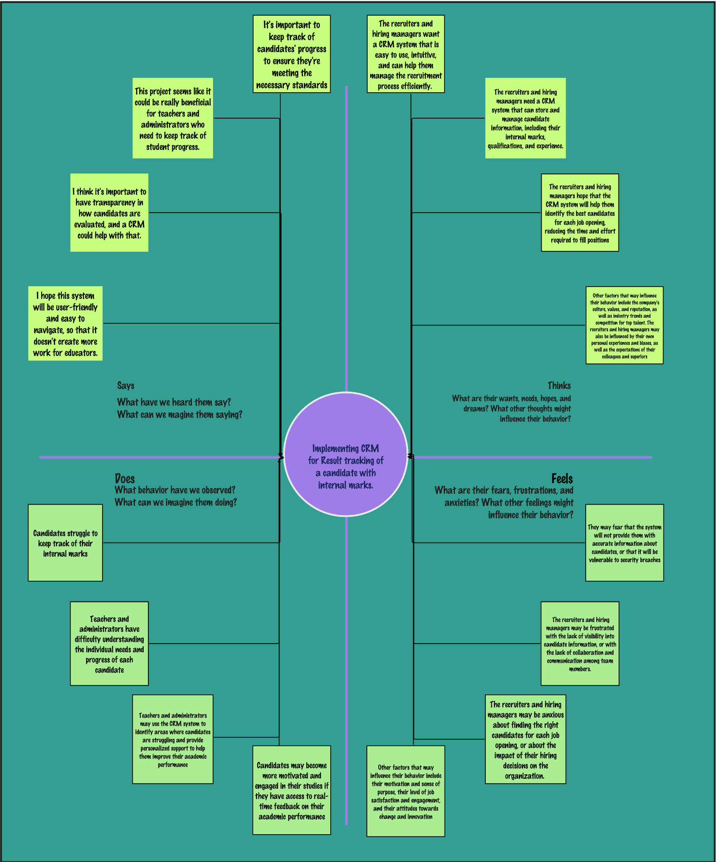

*2.2 Ideation & Brainstroming Map*

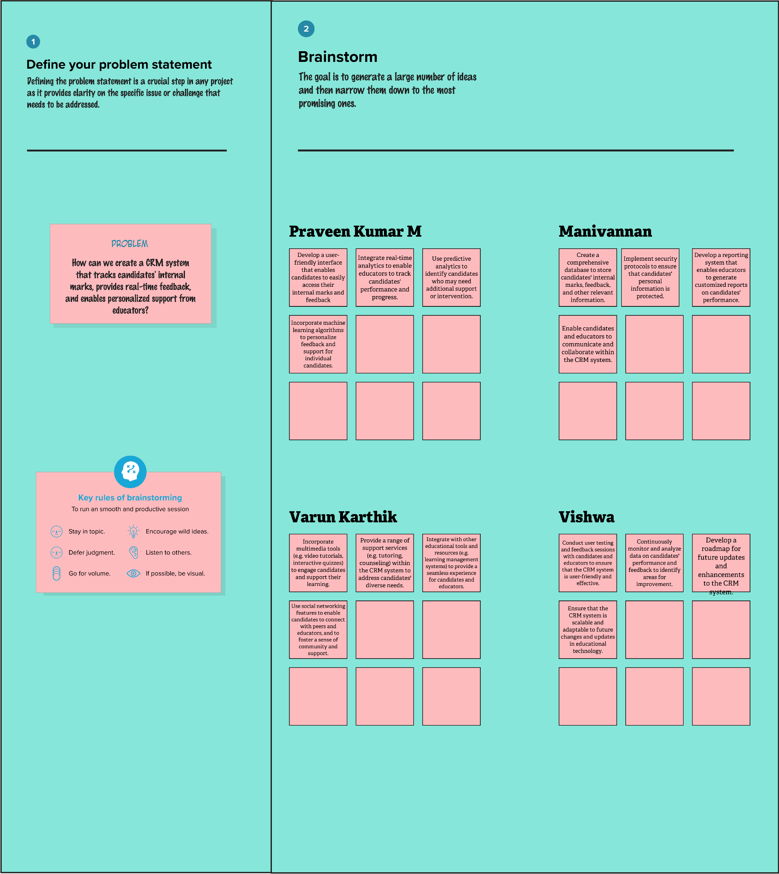

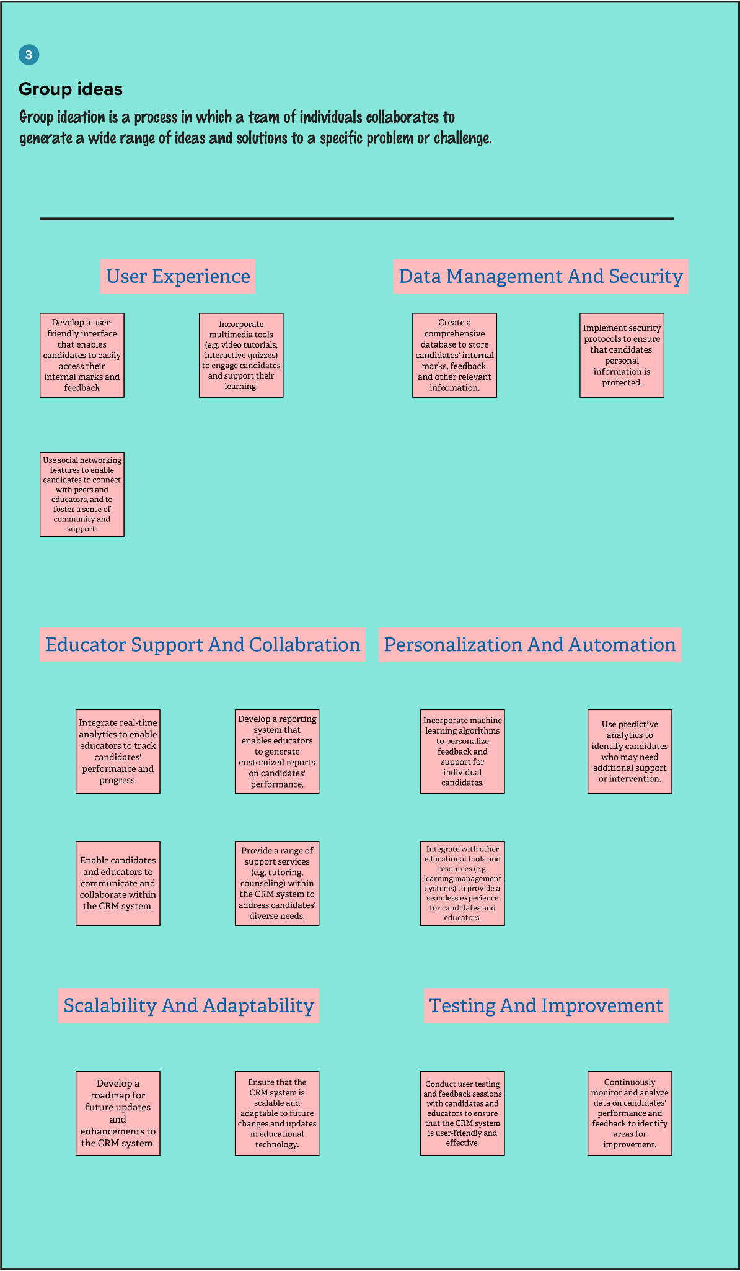

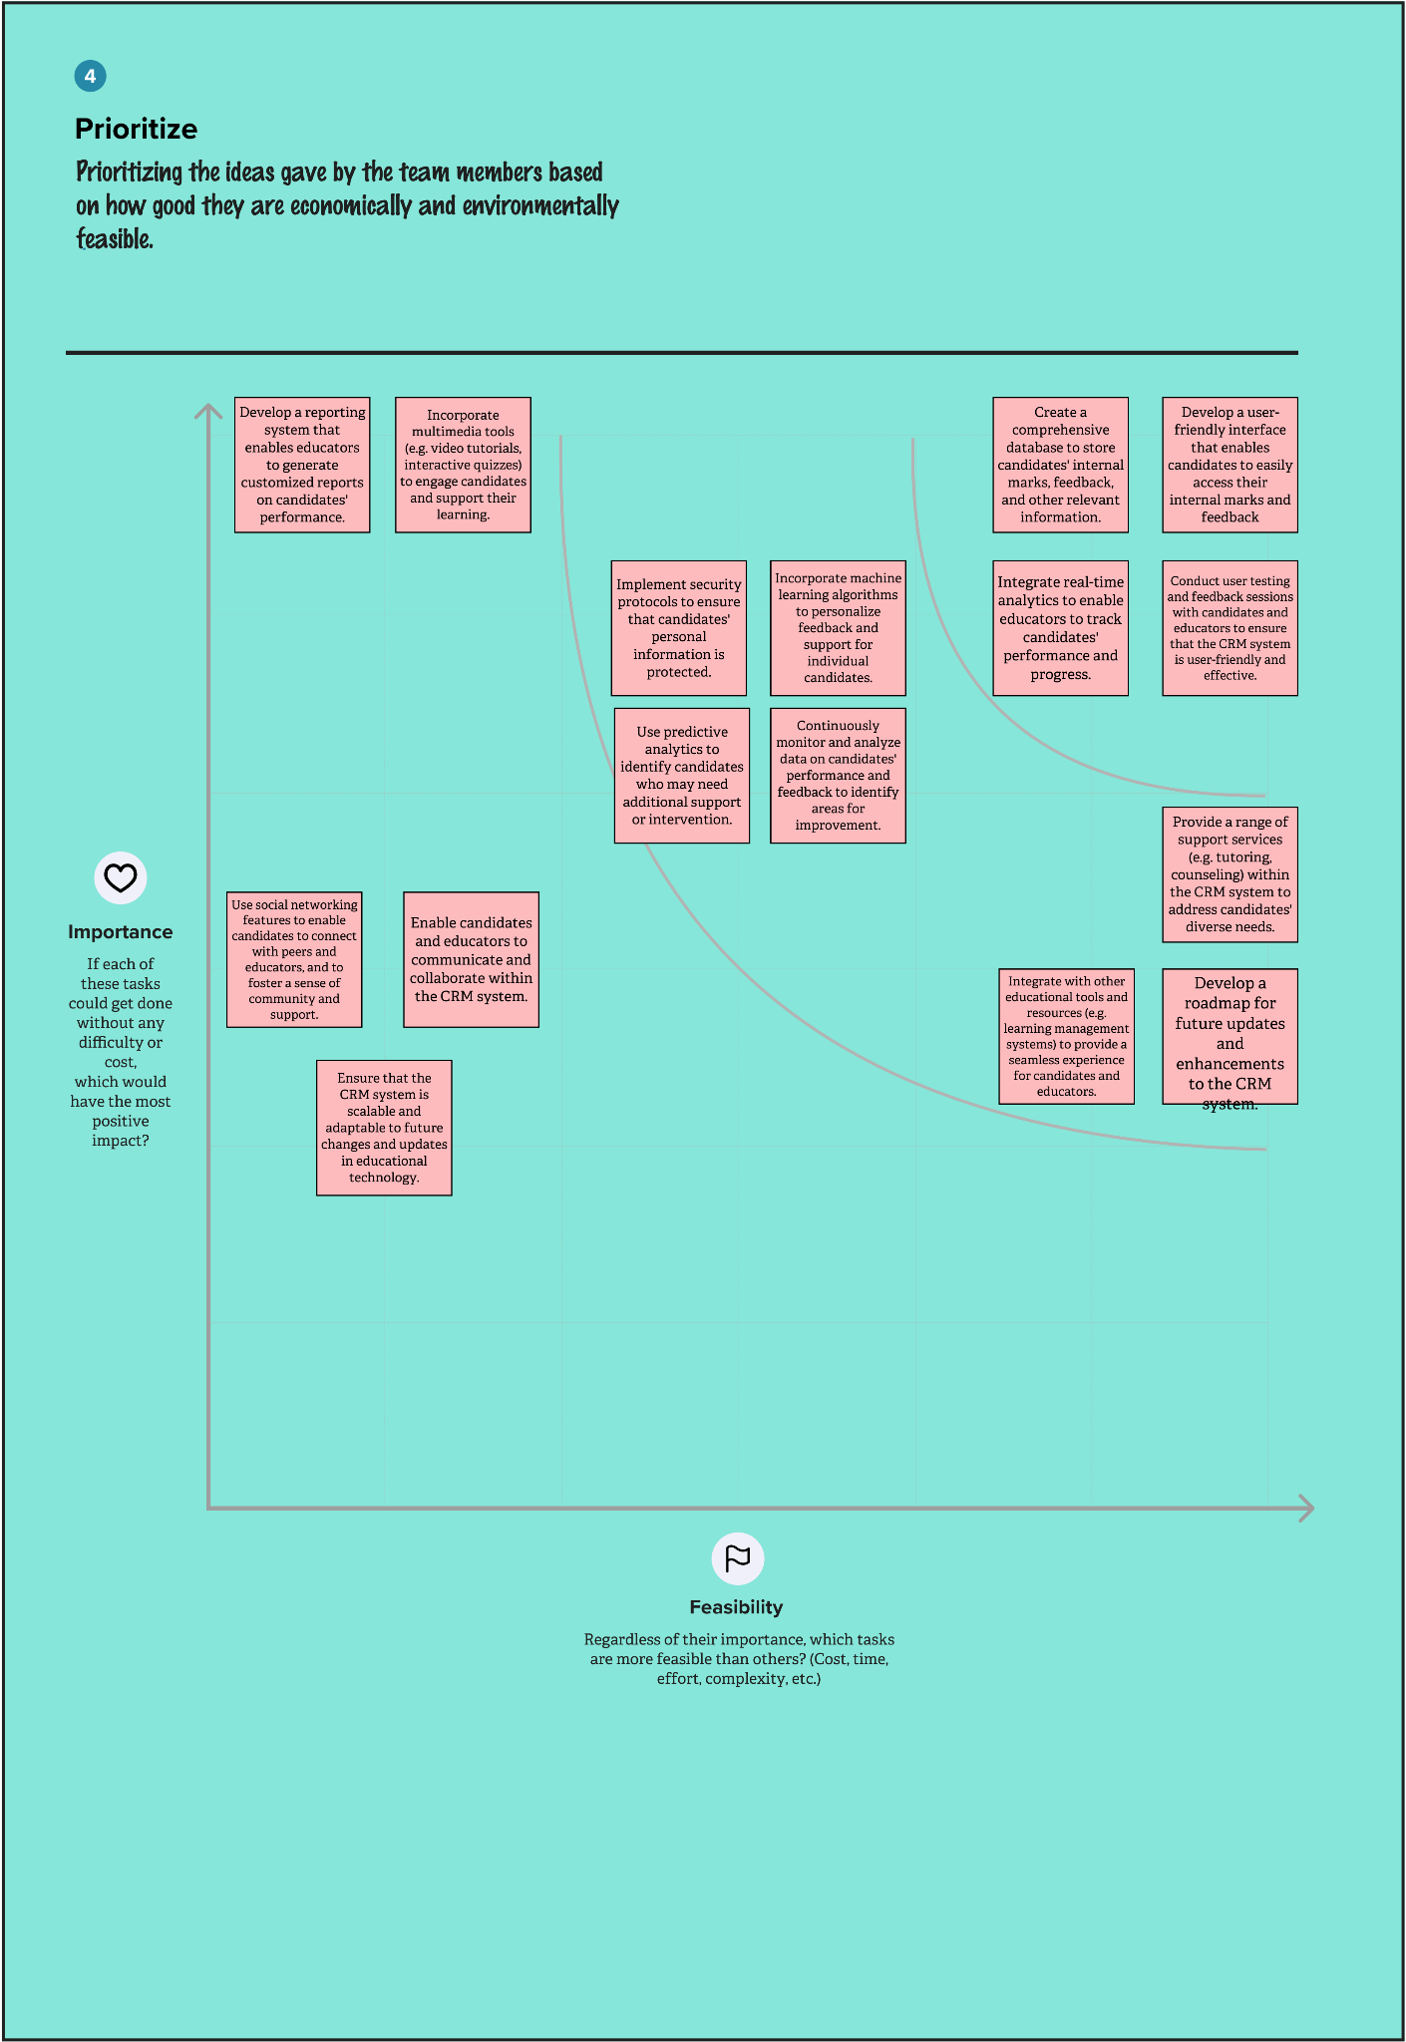

**3 RESULT`**

***3.1 Data Model:***

| **Candidate** | | **Field Label** | **Data Type** | | --- | --- | | Candidate Name | text(80) | | Candidate’s Name | text(20) | | Candidate’s Marks | Number(3,2) | |
| --- | --- | --- | --- | --- | --- | --- | --- | --- | --- |
| **Semester** | | **Field Label** | **Data Type** | | --- | --- | | Semester Name | text(80) | | Semester Name | text(20) | |
| **Course Details** | | **Field Label** | **Data Type** | | --- | --- | | Course Details Name | text(20) | | Course Details Name | text(80) | |
| **Lecture Details** | | **Field Label** | **Data Type** | | --- | --- | | Lecture Details | text(20) | | Lecture Details Name | text(80) | |

| **Internal Results** | | **Field Label** | **Data Type** | | --- | --- | | Internal Results | text(20) | | Internal Results Name | text(80) | |
| --- | --- | --- | --- | --- | --- | --- | --- |

***3.2 Activity & Screenshot***

**Semester**

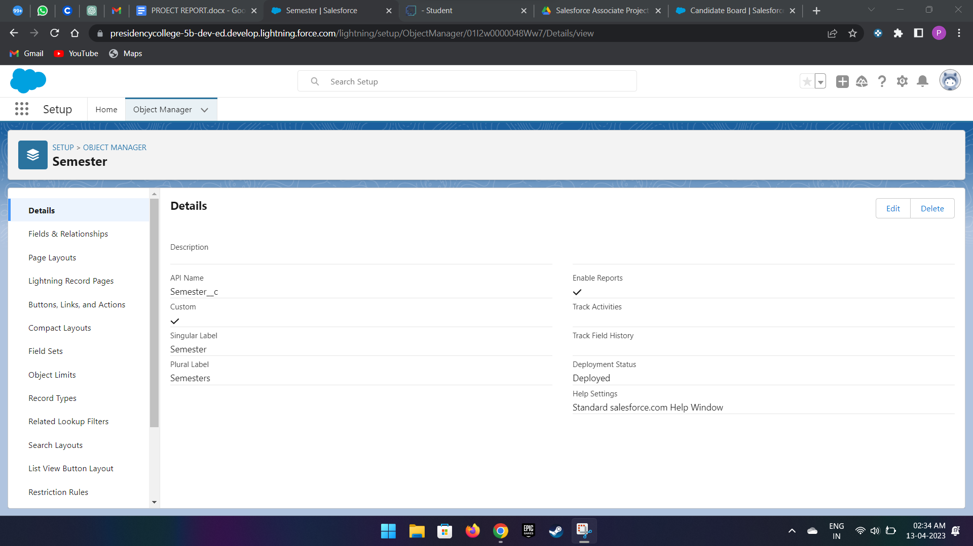

**created some fields and relationships for the object semester**

**Candidate**

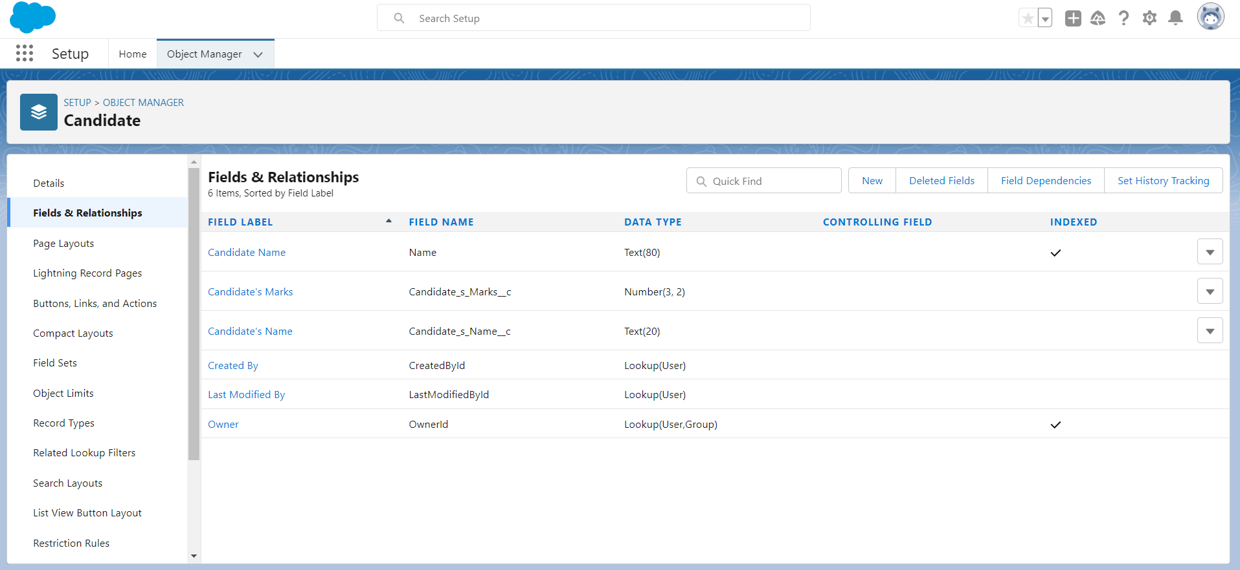

**created some fields and relationships for the object candidate**

**Course Details**

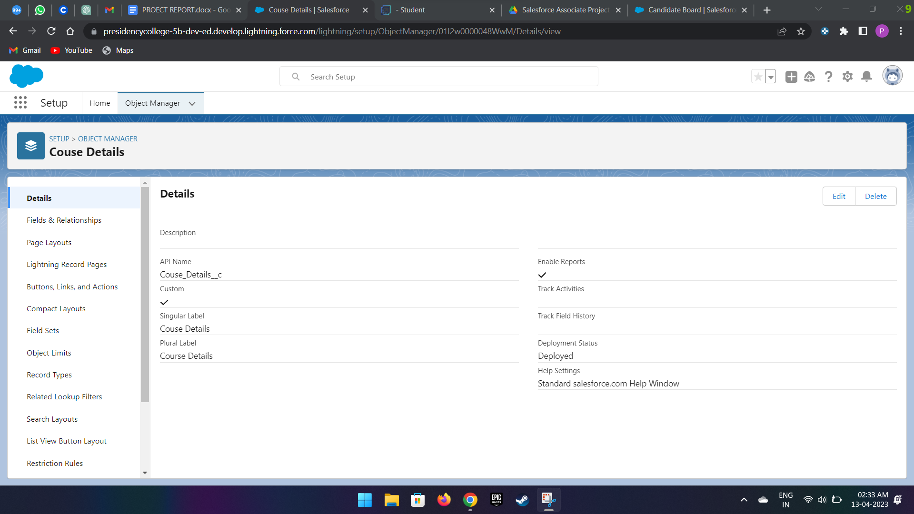

**created some fields and relationships for the object course details**

**Lecture Details**

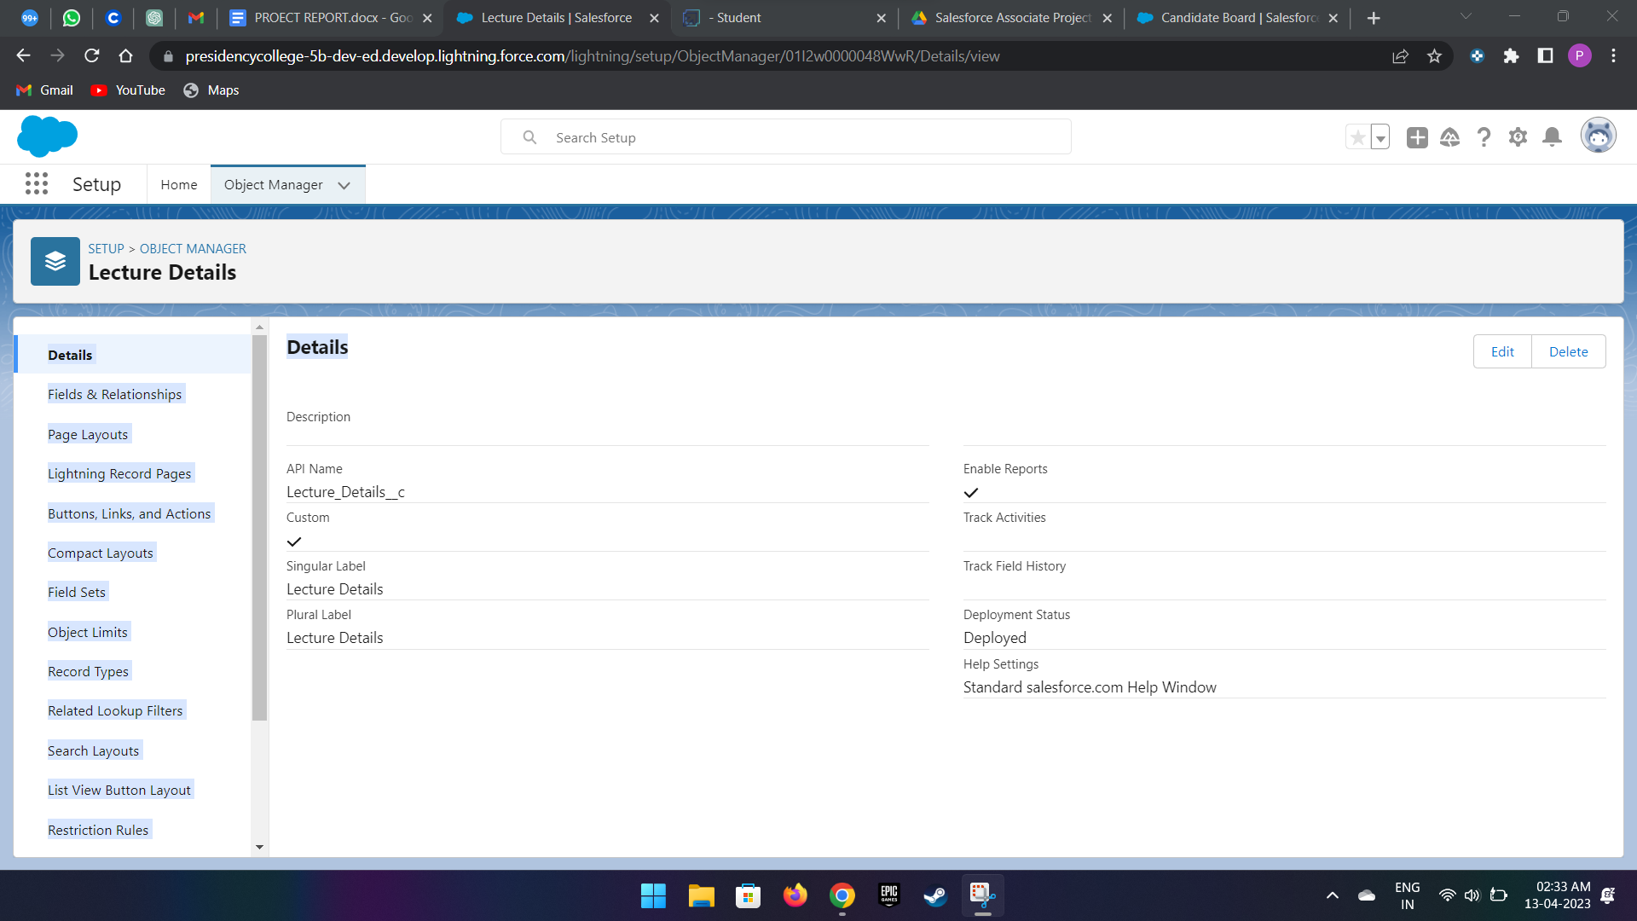

**created some fields and relationships for the object lecture details**

**Internal Results**

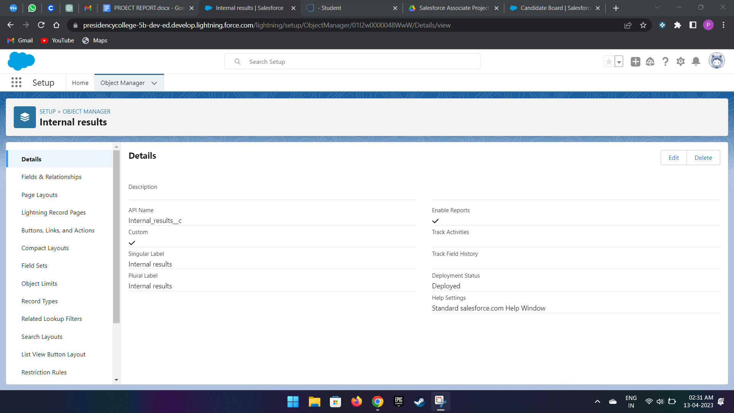

**created some fields and relationships for the object internal results**

**Lightning App**

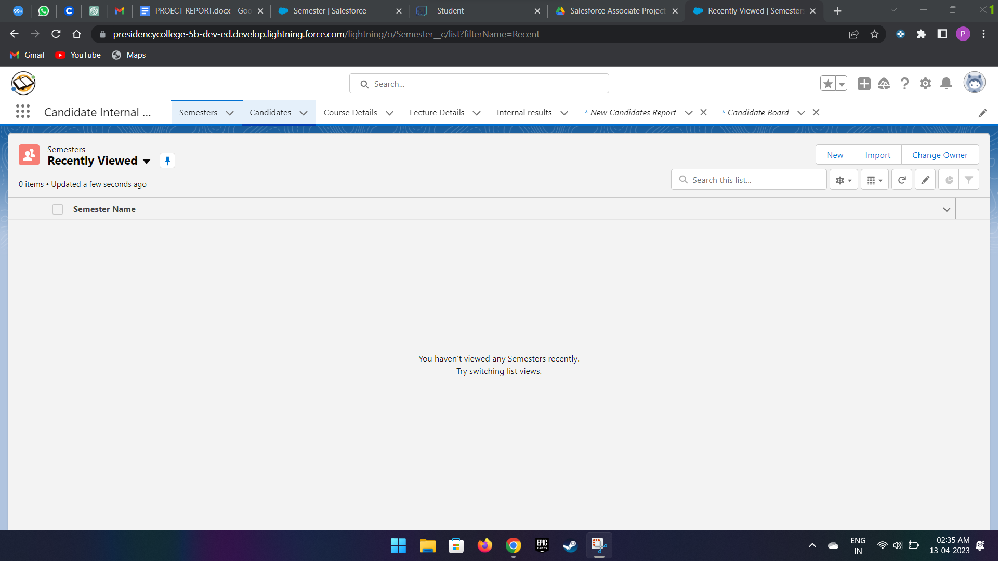

**picture after the creation of lightning app**

**Users**

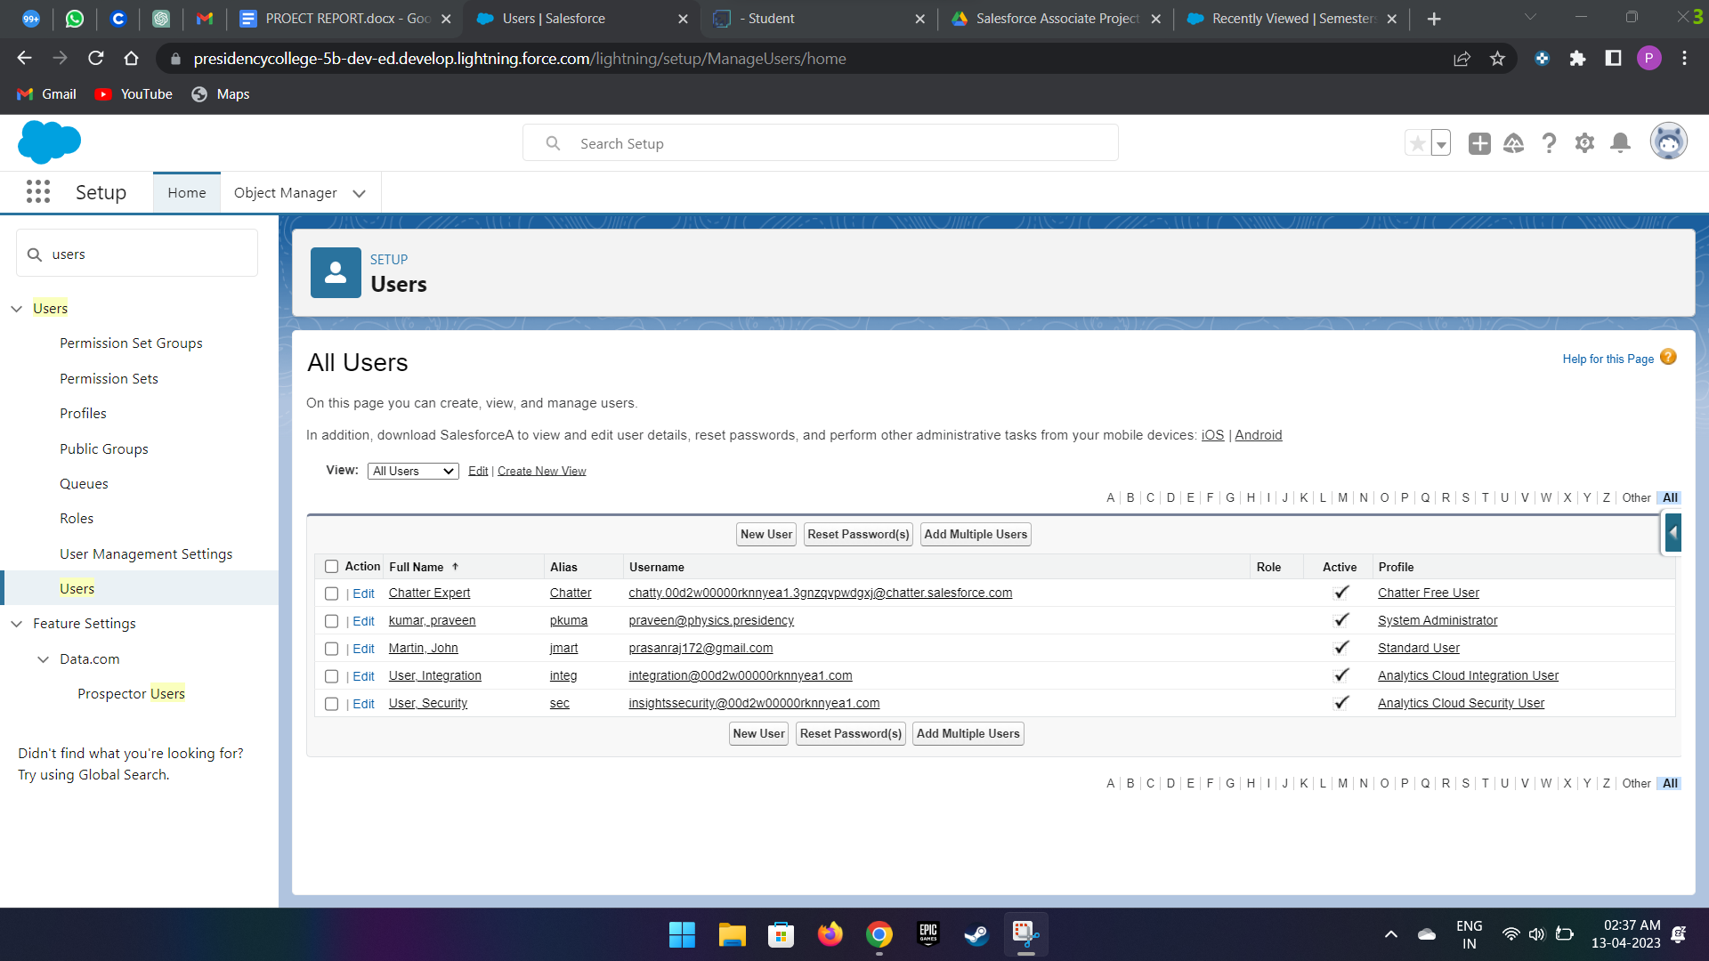

**picture after the creation of example user called martin**

**Reports**

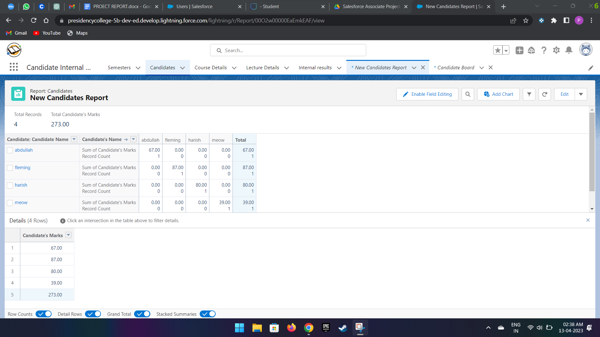

**some tabulated example columns and rows for report section**

**Dashboard**

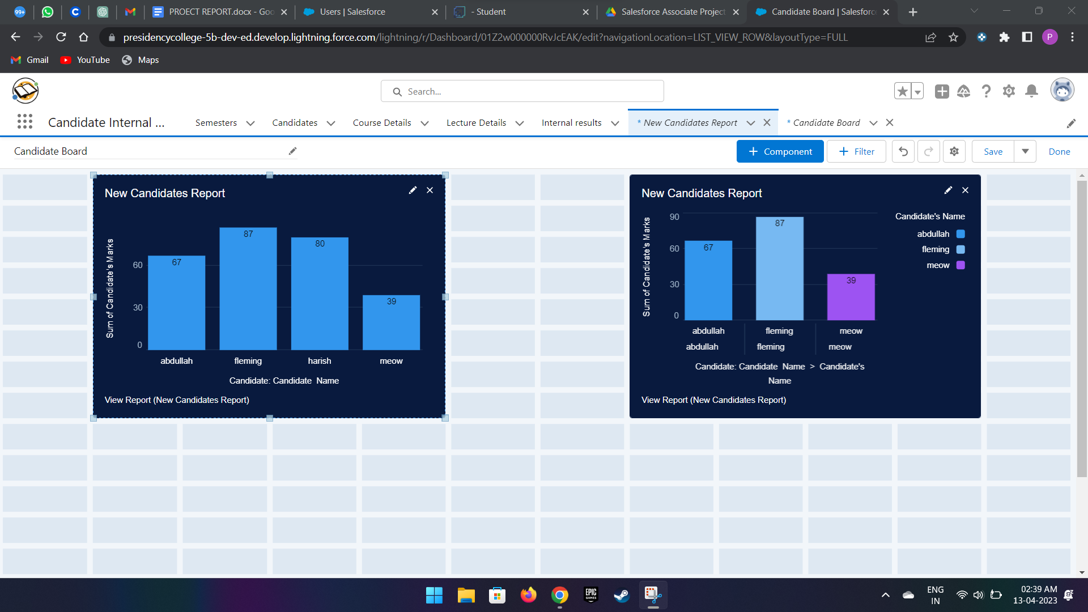

**two examples for candidate marks and their name bar graph for dashboards**

**Trailhead Profile Public URL**

##### **Team Lead – https://trailblazer.me/id/mpkdon007**

##### **Team Member 1- https://trailblazer.me/id/mmani409**

##### **Team Member 2-https://trailblazer.me/id/vishwapresidency05**

##### **Team Member 3-**[**https://trailblazer.me/id/nkarthik31**](https://trailblazer.me/id/nkarthik31)

# Project Report Template

###### ADVANTAGES & DISADVANTAGES

# ADVANTAGES

1)Improved academic record-keeping: The CRM system will provide educators and administrators with quick and easy access to candidate data, improving academic record-keeping processes.

2)Better tracking of internal marks: The system will allow for better tracking of internal marks, enabling educators and administrators to identify areas where candidates may require additional support.

3)Informed decision-making: The system will provide educators and administrators with valuable insights, enabling them to make informed decisions about candidate performance and progress.

4)Enhanced communication and collaboration: The CRM system will improve communication and collaboration between educators and administrators, leading to better decision-making and a more effective academic environment.

5)Improved academic experience for candidates: Ultimately, the implementation of a CRM system will create a more efficient and effective academic environment, improving the academic experience for candidates.

# DISADVANTAGES

1)Implementation costs: Implementing a CRM system can be costly, requiring significant investment in hardware, software, and staff training.

2)Data security risks: Storing candidate data on a CRM system can pose data security risks, requiring measures to be put in place to ensure data is kept secure.

3)Potential for technical issues: Technical issues with the system can occur, leading to disruptions in academic record-keeping and decision-making processes.

4)Resistance to change: Educators and administrators may be resistant to change, requiring a significant effort to ensure that they are fully on board with the implementation of the CRM system.

4)Dependence on technology: The CRM system is dependent on technology, meaning that disruptions to technology can lead to disruptions in academic record-keeping and decision-making processes.

# APPLICATIONS

1)Academic record-keeping: The CRM system can be used to track and maintain accurate academic records for candidates, making it easier for educators and administrators to access relevant information about a candidate's academic performance and progress.

2)Progress tracking: The system can be used to track a candidate's progress through the academic program, identifying areas where additional support may be needed and helping educators and administrators to make informed decisions about candidate development.

3)Performance analysis: The CRM system can be used to analyze candidate performance, identifying trends and patterns in academic achievement and providing educators and administrators with valuable insights into candidate performance and progress.

4)Communication and collaboration: The system can be used to facilitate communication and collaboration between educators and administrators, helping them to work together more effectively towards common goals.

5)Decision-making support: The CRM system can provide educators and administrators with valuable data and insights, helping them to make informed decisions about candidate development, academic program planning, and resource allocation.

6)Candidate support: The CRM system can be used to support candidates, providing them with personalized feedback on their academic performance, identifying areas where additional support may be needed, and helping to develop individualized academic plans.

7)Resource management: The system can be used to manage resources more effectively, helping educators and administrators to allocate resources more efficiently and effectively to support candidate development and academic program delivery.

# CONCLUSION

In conclusion, the implementation of a CRM system for result tracking of a candidate with internal marks has the potential to greatly enhance the academic environment by providing educators and administrators with access to valuable data and insights, improving communication and collaboration, and supporting informed decision-making. While there are potential challenges and disadvantages to implementing such a system, the benefits of doing so are clear. With careful planning, investment, and training, a CRM system can be a powerful tool for improving academic record-keeping, tracking, and decision-making, ultimately leading to a better academic experience for all stakeholders.

# FUTURE SCOPE

1)Increased collaboration: The integration of a CRM system with other academic systems can increase collaboration between educators, administrators, and candidates, enabling them to work together more efficiently and effectively.

2)Predictive modeling: Predictive modeling algorithms can be used to identify candidates who may be at risk of academic failure or dropping out, enabling educators and administrators to provide targeted support and interventions.

3)Enhanced student engagement: The use of mobile apps and other innovative technologies can enhance student engagement by providing candidates with real-time access to their academic records and performance data, enabling them to track their progress and stay motivated.

4)Adaptive learning: The integration of a CRM system with adaptive learning technologies can enable educators to tailor academic programs and learning resources to the specific needs and preferences of individual candidates, improving their learning outcomes.

5)Blockchain integration: The integration of blockchain technology can enhance the security and transparency of academic records, ensuring that candidate data is stored securely and is tamper-proof.

6)Personalized learning: The integration of a CRM system with personalized learning technologies can enable educators to create customized learning paths for individual candidates, based on their interests, abilities, and learning style.

7)Augmented Reality (AR) and Virtual Reality (VR) integration: The integration of AR and VR technologies can create immersive learning experiences for candidates, enabling them to visualize complex concepts and theories more easily and interact with learning resources in a more engaging way.